**KENEXOFT’S SDME SMART DIGITAL MONITORING ENGINE**

**Internship report submitted in partial fulfillment of the Requirements for the Award   
of the Degree of**

**BACHELOR OF TECHNOLOGY**

**In**

**COMPUTER SCIENCE AND ENGINEERING**

**by**

**SHAIK SAMEER**

**(198W1A05B5)**



**DEPARTMENT OF COMPUTER SCIENCE AND ENGINEERING**

**V.R. SIDDHARTHA ENGINEERING COLLEGE**

**Autonomous and Approved by AICTE - Twice Accredited by NBA**

**Affiliated to Jawaharlal Nehru Technological University, Kakinada**

**Vijayawada – 520007**

**2022**

**V.R. SIDDHARTHA ENGINEERING COLLEGE**

**(AUTONOMOUS)**

**DEPARTMENT OF COMPUTER SCIENCE AND ENGINEERING**



**CERTIFICATE**

This is to certify that the Internship report entitled “**KENEXOFT’S SDME SMART DIGITAL MONITORING SYSTEM**” being submitted by “**SHAIK SAMEER**” “**198W1A05B5**“is work done by him/ her and submitted during 2022– 2023 academic year, in partial fulfillment of the requirements for the award of the degree of BACHELOR OF TECHNOLOGY in **COMPUTER SCIENCE AND ENGINEERING**, at “**KENEXOFT TECHNOLOGIES PVT LTD, HYDERABAD**” from **20th JUNE 2022** To **26th AUGUST 2022**.

**Internship Co-Ordinator**

**Dr. G. Anuradha**

**M.Tech., Ph.D.**

**Head of the Department**

**Dr. D. Rajeswara Rao**

**M.Tech., Ph.D.**

**DECLARATION**

I hereby declare that the internship project titled **“KENEXOFT’S SDME: SMART DIGITAL MONITORING SYSTEM”** submitted for B.Tech. degree is my original work done in the internship period with Kenexoft Technologies Pvt Ltd and the dissertation has not formed the basis for the award of any degree, associateship, fellowship or any other similar titles.

**SHAIK SAMEER**

**(198W1A05B5)**

**Place:** Vijayawada

**Date:**

**INTERSHIP OFFER LETTER ISSUED BY COMPANY**



**COMPANY PROFILE AND EXTERNAL GUIDE DETAILS**

Kenexoft Technologies is a Start-up India & DPIIT (DIPP) Certified, Private Limited IT Company, enabling our clients in creation and execution of strategies for their Digital Transformation & hence Business Transformation. The name “Kenexoft” is derived from our TEAM’s vision and passion of making Kenexoft the ‘K‘ey ‘E‘nabler by providing ‘NEX‘t generation ‘SOFT‘ware technology services that would contribute to and facilitate our clients in achieving business excellence.

Kenexoft offers Current & Next Generation technologies based IT Solutions & IT Services ranging from Enterprise Web & Mobile Application Development, Application Maintenance, Independent Testing, Test Automation Services, Dev-Ops & Dev-Ops Automation Services, ITIL compliant IT Infrastructure Management Services, to Business Process Automation using RPA, IOT implementations, Data Visualization & Data Analytics and ML/AI implementations. Kenexoft helps enabling collaboration of digital systems, platforms & automated processes for higher precession, quality and productivity yielding enhanced ROI, reduced costs and increased profit margins.

Kenexoft believes in collaboration and mutual growth. Apart from its own IT Solutions & IT Services, Kenexoft promotes the IT Products of current & emerging IT Product companies. A Next GEN ERP system that is highly customizable with quick turn around time compared to traditional ERP systems, affordable for SMEs aspiring to gain the advantage of implementing ERP systems for their businesses and for Large Enterprises alike; is being promoted by Kenexoft.

**External Guide:**

**Name:** Mr. Krishna Ivantury

**Designation:** Machine Learning (ML) Python Developer

**E-Mail Address:** [Ikrishna@Kenexoft.com](mailto:balasuriya.k@zohocorp.com)

**Work Location:** Hyderabad

**WORK RESPONSIBILITIES**

The role that I have been offered is the Python Developer in the company , as an opportunity to work with Kenexoft Technologies , which develops Kenexoft offers Current & Next Generation technologies based IT Solutions & IT Services ranging from Enterprise Web & Mobile Application Development, Application Maintenance, Independent Testing, Test Automation Services, Dev-Ops & Dev-Ops Automation Services, ITIL compliant IT Infrastructure Management Services, to Business Process Automation using RPA, IOT implementations, Data Visualization & Data Analytics and ML/AI implementations. Kenexoft helps enabling collaboration of digital systems, platforms & automated processes for higher precession, quality and productivity yielding enhanced ROI, reduced costs and increased profit margins.

Kenexoft believes in collaboration and mutual growth. Apart from its own IT Solutions & IT Services, Kenexoft promotes the IT Products of current & emerging IT Product companies. A Next GEN ERP system that is highly customizable with quick turnaround time compared to traditional ERP systems, affordable for SMEs aspiring to gain the advantage of implementing ERP systems for their businesses and for Large Enterprises alike; is being promoted by Kenexoft.

**TECHNICAL RESPONSIBILITIES:**

* Learning the foundations of CNN (convolutional Neural Networks), work environment, of Deep Learning, and fundamentals of Machine Learning
* Educating myself about the technology that governs Machine learning and all the services provided by AI & ML
* To study and develop a model, by passing the certification examination, by making use of the courses and resources provided by kenexoft.
* Collaborating with a team in completing the assigned internship project.
* People in this team are interns from IIIT Hyderabad and CBIT and OSMANIA UNIVERSITY From Hyderabad who have been selected for the same role. The project that I was assigned was to develop a highly demanded Feature.
* First of all, this project has been divided into the parts which was split between team

**NON-TECHNICAL RESPONSIBILITIES:**

* Interacting with the members of the team virtually and working together as a team.
* Meeting up with the manager for feedback.
* Constantly meeting with the project mentors and updating them about the progress in the project and the future works that are to be carried out, and progressively work on the feedback.
* Developing professionalism.
* Portraying leadership skills and making sure my thoughts are heard and are evaluated.

**INTERNSHIP COMPLETION CERTIFICATE**



**TABLE OF CONTENTS**

Contents

1. INTRODUCTION 1

1.1 BASIC CONCEPTS 1

**1.1.1 ARTIFICIAL INTELLIGENCE(AI)`** 1

**1.1.2 DEEP LEARNING** 2

**1.1.3 CONVOLUTIONAL NEURAL NETWORKS** 2

**1.1.4 ARTIFICIAL NEURAL NETWORKS** 3

**1.1.5 MEACHINE LEARNING** 3

**1.1.6 OPENCV2** 4

**1.1.7 MONGO DB** 5

1.2 MOTIVATION 5

1.3 PROBLEM STATEMENT 5

1.4 OBJECTIVE 6

1.5 SCOPE 6

1.6 ADVANTAGES 7

2. EXISTING SYSTEM 8

2.1 GENDER DETECTION 8

2.2 ADVANTAGES 10

2.3 DISADVANTAGES 11

3. SOFTWARE REQUIREMENT ANALYSIS 12

3.1 FUNCTIONAL REQUIREMENTS 12

**3.1.1 CONVOLUTIONAL NEURAL NETWORKS:** 12

4. SOFTWARE DESIGN 18

4.1 DATA FLOW DIAGRAM (DFD): 18

**4.1.1 PLAN AND ANALYSE** 20

**4.1.2 IDENTIFY** 20

**4.1.3 IMPLEMENT** 20

**4.1.4 TEST** 20

**4.1.5 GO-LIVE** 20

4.2 UML Diagrams 21

**4.2.1 USE CASE DIAGRAMS** 22

**4.2.2 SEQUENCE DIAGRAMS** 25

**4.2.3 ACTIVITY DIAGRAM** 27

5. METHODOLOGY 31

6. TESTING 34

6.1 STEPS IN TESTING PROJECT 34

**6.1.1 UNDERSTAND THE BUSINESS PROCESS** 34

**6.1.2 TEST** 34

**6.1.3 TEST SCRIPTS** 35

**6.1.4 TEST THE DATA** 35

**6.1.5 MANAGE THE DEFECTS** 35

7. OUTPUT & SAMPLE CODE 36

8. CONCLUSION 53

**ABSTRACT**

This project's major goal is to employ an AI-enabled SDME which is a real-time application (Framework). It is used to enable computers to execute executive functions such as decision-making, problem-solving, perception, and understanding human communication. We use AI to make a convolutional neural network (CNN), a python-based deep learning module that extracts streams, identifies, and processes images, and collects snapshots from videos before storing the data in the cloud. It has been developed in the existing AI-based Smart Identification Engine that can capture the Age, Gender of a particular person in real-time using an IP-enabled camera at malls and public places for advertisement and store that information in the cloud/physical storage (with real-time video analysis). **Convolutional Neural Networks** are a type of neural network that is mostly used for image classification, picture clustering, and object identification. Face recognition is one of CNN's key applications. Deep convolutional neural networks are preferred over other neural networks for achieving the highest accuracy. Convolutional Neural Networks (CNNs) are a form of feed-forward artificial neural network whose connection pattern is inspired by the visual cortex.

In the proposed system, we use an IP enabled camera that can be linked by providing an Ip address; from this video source, we record the videos and, ideally, store the information of the videos in a Cloud/Physical storage by splitting the video into image, which is an output produced using AI techniques. AI enabled Smart Digital Monitoring Engine (SDME) is an effective implementation of AI’s convolutional Neural Network (CNN), a class of Deep Neural Networks to identify and process images and videos. AI enabled SDME framework can be used for various sectors and scenarios such as:

A) Playing relevant Ads in Retail Malls based on the Gender/Avg. Age/Moods of the audience watching the LED screens playing the Ads.

B) To automate the identification of Owners/ Tenants Vs Guests/Visitors in a Gated Community, through face recognition and vehicle no. recognition, and scalable for automation of gate/boom barrier opening/closing & more…

**Keywords:** CNN (convolutional Neural Networks), Age and Gender Detection, OpenCV, TensorFlow, Tesseract.

# **1. INTRODUCTION**

## **1.1 BASIC CONCEPTS**

### **1.1.1 ARTIFICIAL INTELLIGENCE(AI)`**

is the fastest developing computer science technology that is used to construct intelligent devices that decrease human work. Artificial intelligence is all around us and has enormous potential in the future. Artificial intelligence is created when a machine can do human-like functions such as learning, thinking, and problem solving. AI assists in the development of software devices that can handle real-world problems extremely precisely, for example, AI utilized in traffic concerns, marketing, and so on. AI aids in the development of personal virtual assistants such as Cortana, Google Voice Assistant, Siri, and others. We also construct robots to eliminate human hazards. AI opens the door to several additional technologies and new prospects in the future. The primary goal of artificial intelligence is to imitate human intellect in order to accomplish complex problems, as well as to develop systems that can display intelligent behaviour, learn new things on their own, illustrate, explain, and advise its users.

In today's culture, artificial intelligence has several uses. It is becoming increasingly important in today's world since it can address complicated issues in a variety of areas, including healthcare, entertainment, banking, and education. AI is making our daily lives more convenient and efficient.

The following are some industries that use artificial intelligence Fig 1:

* Data Security
* Gaming
* Finance
* Social Media
* Automotive
* Robotics
* Entertainment
* E-Commerce
* Education
* Agriculture
* Transport
* Health Care

### **1.1.2 DEEP LEARNING**

Deep learning is a form of machine learning that incorporates neural networks that mimic the human brain. Deep learning is a type of machine learning that employs a large number of nonlinear processing units to extract and manipulate features. Each succeeding layer takes the output of the preceding layer as input, especially we use deep learning when we have a huge no of inputs and outputs. Deep learning is **a subset of machine learning**, which is essentially a neural network with three or more layers. These neural networks attempt to simulate the behaviour of the human brain—albeit far from matching its ability—allowing it to “learn” from large amounts of data

Deep learning is accomplished with the aid of Neural Networks,[4] and the concept behind the inspiration of Neural Network is biological neurons, which are nothing more than brain cells.

### **1.1.3 CONVOLUTIONAL NEURAL NETWORKS**

To reiterate from the [Neural Networks](https://www.ibm.com/cloud/learn/neural-networks)  **Convolutional Neural Networks** are a type of neural network that is mostly used for image classification, picture clustering, and object identification. Face recognition is one of CNN's key applications. Deep convolutional neural networks are preferred over other neural networks for achieving the highest accuracy. Convolutional Neural Networks (CNNs) are a form of feed-forward artificial neural network whose connection pattern is inspired by the visual cortex.

Convolutional Neural Networks, or covnets, are nothing more than neural networks that share parameters. Assume there is an image that is encapsulated as a cuboid with dimensions of length, width, and height. The picture dimensions are represented here by the red, green, and blue channels.CNN's construction A Convolutional Neural Network is created by adding an extra layer known as convolutional that gives an eye to the Artificial Intelligence or Deep Learning model because it allows us to easily take a 3D frame or image as an input as opposed to our previous artificial neural network, which could only take an input vector containing some features as information. However, in this case, we will add a convolutional layer at the front that will be capable of seeing pictures in the same way that humans do

### **1.1.4 ARTIFICIAL NEURAL NETWORKS**

Artificial neural network" refers to a biologically inspired sub-field of artificial intelligence modelled after the brain. An Artificial neural network is usually a computational network based on biological neural networks that construct the structure of the human brain. Similar to a human brain has neurons interconnected to each other, artificial neural networks also have neurons that are linked to each other in various layers of the networks. These neurons are known as nodes. An **Artificial Neural Network** in the field of **Artificial intelligence** where it attempts to mimic the network of neurons makes up a human brain so that computers will have an option to understand things and make decisions in a human-like manner. The artificial neural network is designed by programming computers to behave simply like interconnected brain cells.

There are around 1000 billion neurons in the human brain. Each neuron has an association point somewhere in the range of 1,000 and 100,000. In the human brain, data is stored in such a manner as to be distributed, and we can extract more than one piece of this data, when necessary, from our memory parallelly. We can say that the human brain is made up of incredibly amazing parallel processors.

### **1.1.5 MEACHINE LEARNING**

**Machine learning** is a growing technology which enables computers to learn automatically from past data. Machine learning uses various algorithms for building mathematical models and making predictions using historical data or information. Currently, it is being used for various tasks such as image recognition**,** speech recognition, email filtering, Facebook auto-tagging, recommender system, and many more.,

. A Machine Learning system learns from historical data, builds the prediction models, and whenever it receives new data, predicts the output for it. The accuracy of predicted output depends upon the amount of data, as the huge amount of data helps to build a better model which predicts the output more accurately.

Suppose we have a complex problem, where we need to perform some predictions, so instead of writing a code for it, we just need to feed the data to generic algorithms, and with the help of these algorithms, machine builds the logic as per the data and predict the output. Machine learning has changed our way of thinking about the problem. The below block diagram explains the working of Machine Learning algorithm:

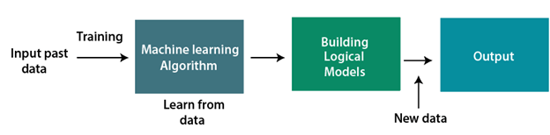

Fig. 1.1.5 Working of Machine Learning Algorithm

### **1.1.6 OPENCV2**

The OpenCV (Open-Source Computer Vision Library) is an open-source computer vision and machine learning software library. OpenCV was built to provide a common infrastructure for computer vision applications and to accelerate the use of machine perception in the commercial products. Being an Apache 2 licensed product, OpenCV makes it easy for businesses to utilize and modify the code. Using OpenCV, you can pretty much do every Computer Vision task that you can think of. Real-life problems require you to use many blocks together to achieve the desired result. So, you just need to understand what modules and functions to use to get what you want. Let's understand what OpenCV can do out of the box.

One of the best things about OpenCV is that it provides a lot of in-built primitives to handle operations related to image processing and Computer Vision. If you have to write something from scratch, you will have to define things, such as an *image*, *point*, *rectangle*, and so on. These are fundamental to almost any Computer Vision algorithm. OpenCV comes with all these basic structures out of the box, and they are contained in the core module. Another advantage is that these structures have already been optimized for speed and memory, so you don't have to worry about the implementation details. The imgcodecs module handles reading and writing image files. When you operate on an input image and create an output image, you can save it as a jpg or a png file with a simple command. You will be dealing with a lot of video files when you are working with cameras. The video module handles everything related to the input/output of video files. You can easily capture a video from a webcam or read a video file in many different formats. You can even save a bunch of frames as a video file by setting properties such as frames per second, frame size, and so on. (Image processing operations)

Fig. 1.5 Control Room

### **1.1.7 MONGO DB**

Mongo DB is the Document Database with the scalability and flexibility that you want with the Querying and the indexing that you need. MongoDB is **NOSQL Database** While the MongoDB document model offers flexibility and an intuitive API loved by developers, self-managing MongoDB databases is difficult, time-consuming, and expensive, especially as applications scale. AWS created Amazon Document DB (with MongoDB compatibility) as a fully managed and MongoDB-compatible document database service allowing you to use your existing MongoDB drivers, MongoDB clients, and tools with Amazon Document DB. As a fully managed AWS database service, Amazon Document DB allows you to set up, secure, and scale MongoDB-compatible databases in the cloud without worrying about maintaining and patching database software, manually setting up and securing database clusters, running cluster management software, configuring backups, and monitoring production workloads.

You can migrate MongoDB workloads to Amazon Document DB using the [AWS Database Migration Service (AWS DMS)](https://aws.amazon.com/dms/) and [command line utilities like mongo dump and mongo restore](https://docs.aws.amazon.com/documentdb/latest/developerguide/backup_restore-dump_restore_import_export_data.html).

## **1.2 MOTIVATION**

On This project's major goal is to employ an AI-enabled SDME which is a real-time application (Framework). It is used to enable computers to execute executive functions such as decision-making, problem-solving, perception, and understanding human communication. We use AI to make a convolutional neural network (CNN), a python-based deep learning module that extracts streams, identifies and processes images, and collects snapshots from videos before storing the data in the cloud.

## **1.3 PROBLEM STATEMENT**

The problem statement is "First Access the Video from the IP enabled camera from which the video is been chopped into the frames and in that many frame images we will delete the unnecessary Blur Images from the folder and upload the remaining images into the Cloud/Database and then by the Convolutional Neural Networks we will process the images and snapshots and classify the gender using the gender detection model and play the relevant advertisement based on the gender.

## **1.4 OBJECTIVE**

Playing relevant Ads in Retail Malls based on the Gender/Avg. Age/Moods of the audience watching the LED screens playing the Ads. B) To automate the identification of Owners/ Tenants Vs Guests/Visitors in a Gated Community, through face recognition and vehicle no. recognition, and scalable for automation of gate/boom barrier opening/closing & more

## **1.5 SCOPE**

The scope of this project is:

* Prototype which is limited only to the small database
* It applies only to the two categories of Gender (Male & Female).

**Future Scope**

The implementation of vehicle detection, which requires reading the text on the licence plate and determining whether the vehicle is a member of the community or not by comparing the text with previously registered vehicle numbers that are stored in the database, will be included in the following version. By doing so, we will be able to employ this paradigm in two situations.

1. To only permit registered and approved vehicles to enter the community
2. To create a surveillance system with the purpose of keeping an eye on vehicles entering the community.

The project will be finished by completing the mentioned objective.

## **1.6 ADVANTAGES**

* **Increasing Security:** We need the best type of security to ensure and feel safe this helps in providing the security
* **Secure & Accurate:** There is no limit to the number of processes which need to be executed in this Model. This Model delivers secure and accurate results to any number of processes that you wish to automate.
* **Scalable & Resilient:** It allows scalability with central management. So, all the processes can be automated as per the need and can be monitored centrally
* **Analytics:**Provides extended features to configure *Dashboards* so that the session information can be redirected to the Monitoring Systems.
* **Cloud support:** Provides working capacity support as per the business requirement. So, users have to just create workers on demand and manage them centrally.
* **Execution Intelligence:** Robots connect to systems and react dynamically to the responses in the data on multiple environments.
* **Shorter Time Span for learning:** It can be easily implemented in the short time span of 4 to 6 weeks.
* **Makes Shopping more Efficient:** like Shopping by watching the Advertisements by Gender detection is very relatable.
* **Sales:** There will be greater sales for the previously ignored products, this makes the product in booming just by giving the relevant advertisement.

# **2. EXISTING SYSTEM**

## **2.1 GENDER DETECTION**

Web scraping is a method for Gender detection is one of the popular computer vision applications. When you use a camera to detect a person’s gender instead of detecting it on a [**picture**](https://thecleverprogrammer.com/2021/05/15/gender-detection-with-machine-learning/), it can be said to be a real-time gender detection system. So, if you want to learn how to create a real-time gender detection system, this article is for you. In this article, I’ll walk you through the task of real-time gender detection using Python.

**Real-time Gender Detection System**

To create a gender detection system using Python, we need to train a model with some high-level features of the face of human beings such as:

1. **the distance between eyes, nose, and mouth**
2. **and measurements of different parts of the face of both the genders**

There are many libraries and frameworks in Python that can be used to create a real-time gender detection system. Some of these libraries include Yola, TensorFlow, OpenCV, and Cvlib. So here I am going to use the Cvlib library in Python that can be used to detect the gender of a person in a few lines of code.

Along with Cvlib, I will also be using the OpenCV library in Python so that we can detect a person’s gender using a webcam. So here is how to install both libraries on your system using the pip command:

1. **pip install opencv-python**
2. **pip install cvlib**

**Real-time Gender Detection using Python**

Hope you have easily installed the two libraries we need to detect the gender of a person I mentioned above. Now here is how to detect a person’s gender with Python in real-time using a webcam:

First of all, it should be noted that [**gender detection and age detection**](https://www.cameralyze.co/demographic-analysis-in-computer-vision) are not easy tasks, and such tasks are complex even for us humans. While even two people of the same age and gender can look completely different from each other, it is a significant development that machines can successfully make these identifications. For example, long hair is an appearance trait usually associated with women, but this is not typically the case. Therefore, it is a complex process for technologies to make the correct detection.

The basis of [**age detection and gender detection**](https://www.cameralyze.co/blog/8-ways-demographic-analysis-solutions-benefits-your-business)in such applications is face detection technology. After artificial intelligence determines the faces in the image, it analyzes the gender and age of these faces and allows you to obtain statistics.

These are highly sophisticated algorithms and extremely difficult to use. In order to be able to perform such complex tasks and to make correct identifications, the algorithm needs to be trained with very large datasets. Today, Deep Learning algorithms are widely used for this, but companies such as Microsoft also develop software for these processes. The common side of this software is that it requires detailed knowledge, which means time and budget. On the other hand,web-based artificial intelligence solutions such as Cameraylze are at your side to meet the needs of your business.  
These web-based technologies can provide you with detailed analyses, for example:  
·Babys  
·Children  
·Young Adults  
· Old People

The faces of all these age groups may develop differently. For example, algorithm children have upward-facing corners of the mouth, while individuals in their 20s tend to have drooping corners of the mouth. On the other hand, while jaw lines are not sharp in children, they are sharp inyoung adults and middle-aged people.  
‍

In this way, you can get accurate statistics about your customers. After determining which age group and gender prefer your business, you can develop your products and services accordingly. For example, if women mostly prefer your business but can not attract the right age group to your business, you can improve your business with statistics on this.

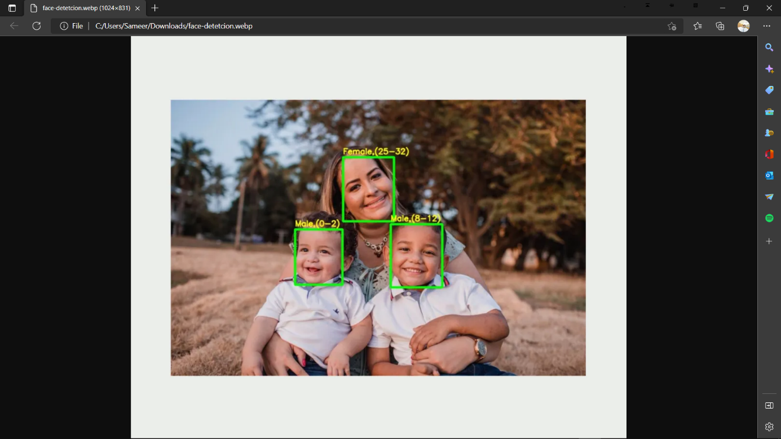

Fig. 2.1 Age Detection

## **2.2 ADVANTAGES**

* **Ease of Use:** Python is simple to code. You do not have to add semi-colons “;” or curly-braces “{}” anywhere. This makes it less messy and easy to use.
* **Large Collection of Libraries:** Python has a huge collection of libraries such as Numpy, Matlplotlib, Pandas etc., which provides methods and services for various purposes. Hence, it is suitable for web scraping and for further manipulation of extracted data.
* **Small code, large task:** Web scraping is used to save time. But what’s the use if you spend more time writing the code? Well, you don’t have to. In Python, you can write small codes to do large tasks. Hence, you save time even while writing the code.
* **Community:** What if you get stuck while writing the code? You don’t have to worry. Python community has one of the biggest and most active communities, where you can seek help from.
* **Automation:** The first and most important benefit of web scraping is developing tools that have simplified data retrieval from different websites to only a few clicks. Data could still be extracted before this approach, but it was a tedious and time-consuming process.
* **Cost-Effective:** Data extraction by hand is an expensive task that necessitates a large workforce and large budgets. Nonetheless, web scraping, like many other digital techniques, has solved this problem.
* **Easy Implementation:** When a website scraping service begins gathering data, you should be confident that you are obtaining data from various websites, not just a single page. It is possible to have a large volume of data with a small investment to help you get the best out of that data.

## **2.3 DISADVANTAGES**

* **Data Analysis:** Processing the extracted data through web scraping can be a time-consuming and energy-intensive process. This is because the information comes as HTML code and that can be difficult for some to read.
* **Website Changes and Protection Policies:** Because websites’ HTML structures change regularly, your crawlers will sometimes break. Whether you use web scraping software or write your own web scraping code, you’ll need to perform some maintenance periodically to ensure your data collection pipelines are clean and operational. Moreover, it’s a good idea to invest in proxies if you want to do data scraping or crawling on multiple pages on the same website. Sending plenty of HTTP requests from the same IP in just a few moments looks suspicious and it could get the IP banned. If you have a proxy pool, though, each request can come from a different IP.
* **Learning Curve:** Web scraping is not just about one way of extracting data. And here, I mean only one tool or the most appropriate method. Whether you use a visual web scraping tool, an API, or a framework, you’ll still have to learn the ropes. This can sometimes be difficult, depending on the knowledge level of each user.

# **3. SOFTWARE REQUIREMENT ANALYSIS**

The following Functional, and Non - Functional Requirements necessary of this project. (Extracting and Generating Reports from E-Commerce Websites)

## **3.1 FUNCTIONAL REQUIREMENTS**

* **Technology:** Gender and Age classification
* **Software:** (CNN)Convolutional Neural Networks, Tensorflow, Tesseract, MongoDB.
* **Software Testing Methodology:** Agile Methodology
* **IDE &Tools: Python** 3.0

**SOFTWARE AND PACKAGES USED IN SDME**

### **3.1.1 CONVOLUTIONAL NEURAL NETWORKS:**

To reiterate from the [Neural Networks](https://www.ibm.com/cloud/learn/neural-networks)  **Convolutional Neural Networks** are a type of neural network that is mostly used for image classification, picture clustering, and object identification. Face recognition is one of CNN's key applications. Deep convolutional neural networks are preferred over other neural networks for achieving the highest accuracy. Convolutional Neural Networks (CNNs) are a form of feed-forward artificial neural network whose connection pattern is inspired by the visual cortex. Convolutional Neural Networks, or covnets, are nothing more than neural networks that share parameters. Assume there is an image that is encapsulated as a cuboid with dimensions of length, width, and height. The picture dimensions are represented here by the red, green, and blue channels.CNN's construction A Convolutional Neural Network is created by adding an extra layer known as convolutional that gives an eye to the Artificial Intelligence or Deep Learning model because it allows us to easily take a 3D frame or image as an input as opposed to our previous artificial neural network, which could only take an input vector containing some features as information. However, in this case, we will add a convolutional layer at the front that will be capable of seeing pictures in the same way that humans do

**3.1.2 TENSORFLOW**

The TensorFlow is a popular framework of machine learning and deep learning. It is a free and open-source library developed by Google Brain Team. It is entirely based on the Python programming language and used for numerical computation and data flow, which makes machine learning faster and easier. TensorFlow can train and run deep neural networks for image recognition, handwritten digit classification, recurrent neural network, word embedding, natural language processing, video detection, and many more. TensorFlow is run on multiple CPUs or GPUs and also mobile operating systems.

It is a free and open-source software library and designed in the Python programming language. This tutorial is designed in such a way that we can easily implement deep learning project on TensorFlow in an easy and efficient way. TensorFlow is completely based on Python. So, it is essential to have basic knowledge of Python. Good understanding of basic mathematics TensorFlow is the best library for all because it is accessible to everyone. TensorFlow library integrates different **API** to create a scale deep learning architecture like **CNN (Convolutional Neural Network)** or **RNN (Recurrent Neural Network)**.and artificial intelligence concepts allow us to understand TensorFlow easily. TensorFlow outperforms other prominent deep learning frameworks in terms of functionality and features. TensorFlow is used to build a multi-layered, large-scale neural network.

**3.1.3 OPENCV**

It is a free and open-source software OpenCV is a Python open-source library, which is used for computer vision in Artificial intelligence, Machine Learning, face recognition, etc. In OpenCV, the CV is an abbreviation form of a computer vision, which is defined as a field of study that helps computers to understand the content of the digital images such as photographs and videos. The purpose of computer vision is to understand the content of the images. It extracts the description from the pictures, which may be an object, a text description, a three-dimensional model, and so on. Computer vision allows the computer to perform the same kind of tasks as humans with the same efficiency. There are a two main task which are defined below:

* **Object Classification -** In the object classification, we train a model on a dataset of particular objects, and the model classifies new objects as belonging to one or more of your training categories.
* **Object Identification -** In object identification, our model will identify a particular instance of an object.

**3.1.4 TESSERACT**

The Tesseract OCR is an optical character reading engine developed by Google. Tesseract has Unicode Support (UTF-8) and can detect more than 100 languages "out of the box" and thus can be used to create different language scanning software. The latest version of Tesseract is Tesseract 4. It adds a new OCR-based neural net (LSTM) engine that focuses on line recognition but also supports the Tesseract OCR legacy engine that works by recognizing character patterns. Tesseract OCR is available for download on all the major operating systems such as Windows, Mac, and OS. To understand the working of OCR, consider the following steps in sequential order:

1. Pre-process image data, for example: switching to gray scale, smooth, de-skew, filter.
2. Detect lines, words and letters.
3. Generate a ranked list of candidate characters based on a set of qualified data sets. (Here the set Datapath () method is used to set trainer data path)
4. Procedure for sending visual characters, select the best characters based on confidence in the previous step with language data. Language data includes dictionaries, grammar rules.

**3.1.5 MONGODB**

MongoDB is an open-source document database that provides high performance, high availability, and automatic scaling.MongoDB is a NoSQL database. It is an open-source, cross-platform, document-oriented database written in C++.MongoDB is a document-oriented database. It is an open-source product, developed and supported by a company named 10gen.MongoDB is available under General Public license for free, and it is also available under Commercial license from the manufacturer.

The manufacturing company 10gen has defined MongoDB as:

"**MongoDB is a scalable, open source, high performance, document-oriented database**." - 10gen

MongoDB was designed to work with commodity servers. Now it is used by companies of all sizes, across all industry Databases can be divided in 3 types:

1. RDBMS (Relational Database Management System)
2. OLAP (Online Analytical Processing)
3. NoSQL (recently developed database)

**NoSQL Database**

NoSQL Database is used to refer to a non-SQL or non-relational database.It provides a mechanism for storage and retrieval of data other than the tabular relations model used in relational databases. NoSQL databases don't use tables for storing data. It is generally used to store big data and real-time web applications.

**MongoDB Database commands**

The MongoDB database commands are used to create, modify, and update the database.

**a) db.adminCommand(cmd)**

The admin command method runs against the admin database to run specified database commands by providing a helper.

**Command:** Either the argument is specified in the document form or a string form. If the command is defined as a string, it cannot include any argument.

**b) db.aggregate()**

The aggregate method initializes a specific diagnostic or admin pipeline, which does not require any underlying collection.

**c) db.cloneDatabase("hostname")**

The clonedatabase method copies the specified database to the current database and assumes that the database at the remote location has the same name as the current database. The hostname parameter contains the hostname of the database that we want to copy

**d) db.commandHelp(command)**

We have the help option for the specified database command using the commandHelp method. The command parameter contains the name of a database command.

**e) db.createCollection(name, options)**

A new collection or view will be created using this method. The createCollection method is used primarily for creating new collections that use specific options when the collection is first referenced in a command.

**f) db.createView()**

When we apply the specified aggregation pipeline to the collection, the createView method creates a new view for the collection. The method can be computed during the read operations and acts as read-only operations. The views can be created in the same database of the source collection to execute read operations as a part of the underlying aggregation pipeline.

**Features of MongoDB**

1. Replication
2. MongoDB supports Master Slave replication.
3. Duplication of data
4. It is a schema-less database written in C++.
5. Provides high performance.
6. Stores files of any size easily without complicating your stack.
7. Easy to administer in the case of failures

**3.2 NON - FUNCTIONAL REQUIREMENTS**

There are various features required for the Blue Prism to create any project.

* Windows Operating System 64-bit (XP, 7, 8, 8.1, 10)
* Processor - 1.4 GHz Quad-Core Intel Core i5
* Memory - 16 GB 2133 MHz LPDDR3
* RAM- 4GB or above(preferred).
* Hard Disk- 1TB or above.
* Monitor Screen- High color 16-bit & 800 x 600 resolutions.
* Microsoft. NET framework.
* Microsoft SQL Server Database.
* Internet Connection- high speed atleast 30mbps
* The tool is based on Python Programming Language and offers a visual designer with drag and drop functionalities. (Python IDLE required)

# **4. SOFTWARE DESIGN**

## **4.1 DATA FLOW DIAGRAM (DFD):**

Data flow diagram is a graphical representation of flow of data in an information system. It can depict incoming data flow, outgoing data flow and stored data. The DFD does not mention anything about how data flows through the system.

There is a prominent difference between DFD and Flowchart. The flowchart depicts flow of control in program modules. DFDs depict flow of data in the system at various levels. DFD does not contain any control or branch elements.

**Types of DFD:**

Data Flow Diagrams are either Logical or Physical.

**Logical DFD**

This type of DFD concentrates on the system process and flow of data in the system. For example, in a Banking software system, how data is moved between different entities.

**Physical DFD**

This type of DFD shows how the data flow is actually implemented in the system. It is more specific and closer to the implementation.

**DFD Components**

DFD can represent Source, destination, storage and flow of data using the following:  
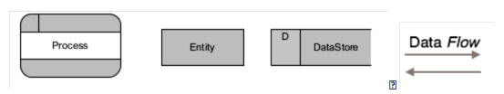

Fig No. 4.1 Components of DFD

**Entities -** Entities are source and destination of information data. Entities are represented by rectangles with their respective names.

**Process -** Activities and action taken on the data are represented by Circle or Round-edged rectangles.

**Data Storage -** There are two variants of data storage - it can either be represented as a rectangle with absence of both smaller sides or as an open-sided rectangle with only one side missing.

**Data Flow -** Movement of data is shown by pointed arrows. Data movement is shown from the base of the arrow as its source towards the head of the arrow as destination.

**LEVELS OF DFD**

**Level 0**

Highest abstraction level DFD is known as Level 0 DFD, which depicts the entire information system as one diagram concealing all the underlying details. Level 0 DFDs are also known as context level DFDs.

**Level 1**

The Level 0 DFD is broken down into more specific, Level 1 DFD. Level 1 DFD depicts basic modules in the system and flow of data among various modules. Level 1 DFD also mentions basic processes and sources of information.

**SDME’s Data Flow Diagram**

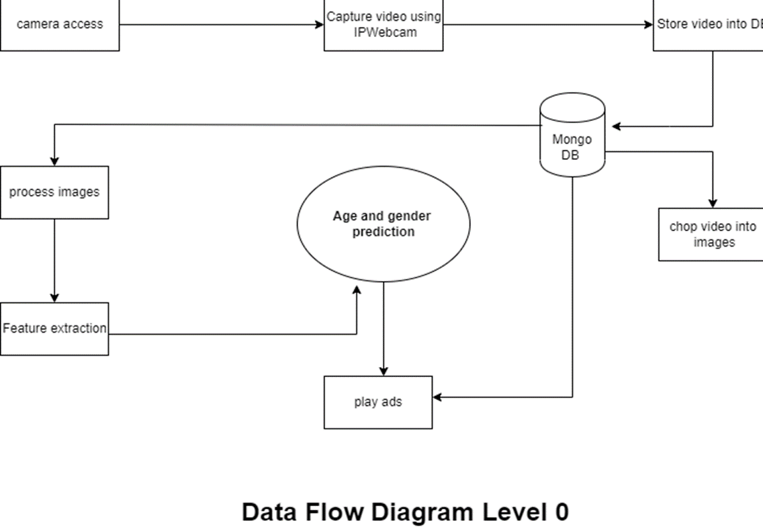

Fig 4.2 SDME’s Data Flow Diagram

### **4.1.1 PLAN AND ANALYSE**

The first step in the SDME’s development process is to analyze a business problem. Business analysts and Project architects are usually in charge of this. Processes that can be automated are identified, timelines for development are established, an approach is documented, and stakeholders' permission is acquired before development can begin.

### **4.1.2 IDENTIFY**

The second step in the Project’s life cycle is to identify the issue and then find an effective solution.

### **4.1.3 IMPLEMENT**

developers automate manual processes by working on requirements in a development environment. The problem statement is "First Access the Video from the IP enabled camera from which the video is been chopped into the frames and in that many frame images we will delete the unnecessary Blur Images from the folder and upload the remaining images into the Cloud/Database and then by the Convolutional Neural Networks we will process the images and snapshots and classify the gender using the gender detection model and play the relevant advertisement based on the gender.

### **4.1.4 TEST**

The developer or QA team tests the SDME’s Prototype Project so that in a staging or testing environment to ensure it runs and functions as intended at this point. Making sure it doesn’t have any issues.

### **4.1.5 GO-LIVE**

After the Prototype has been extensively tested, it will be released into the live environment, where people will be able to use it. It enters the maintenance phase, during which support and change requests for the bot are accepted, and errors are corrected as soon as possible.

## **4.2 UML Diagrams**

UML is a standard language for specifying, visualizing, constructing, and documenting the artifacts of software systems. UML was created by Object Management Group (OMG) and UML 1.0 specification draft was proposed to the OMG in January 1997. OMG is continuously putting effort to make a truly industry standard. UML stands for Unified Modelling Language. UML is a pictorial language used to make software blueprints.

**1) UML Modelling Types:**

It is very important to distinguish between the UML model. Different diagrams are used for different types of UML modelling. There are three important types of UML modelling

**2) Structural modelling:**

Structural modelling captures the static features of a system. They consist of the following: Class diagrams Structural model represents the framework for the system and this framework is the place where all other components exist. So, the class diagrams the part of structural modelling. They all represent the elements and the mechanism to assemble them. But the structural model never describes the dynamic behaviour of the system. Class diagram is the most widely used structural diagram.

**3) Behavioural Modelling:**

Behavioural model describes the interaction in the system. It represents the interaction among the structural diagrams. Behavioural modelling shows the dynamic nature of the system. They consist of the following:

* Activity diagrams
* Sequence diagrams
* Collaboration diagrams
* Use case diagram

### **4.2.1 USE CASE DIAGRAMS**

Use case diagrams are considered for high level requirement analysis of a system. So, when the requirements of a system are analysed, the functionalities are captured in use cases. So, we can say that use cases are nothing, but the system functionalities written in an organized manner. Now the second thing which is relevant to the use cases are the actors. Actors can be defined as something that interacts with the system.

The actors can be human users, some internal applications or may be some external applications. So, in a brief when we are planning to draw a use case diagram, we should have the following items identified.

* Functionalities to be represented as a use case
* Actors
* Relationships among the use cases and actors.
* Use case diagrams are drawn to capture the functional requirements of a system. So, after identifying the above items we have to follow the following guidelines to draw an efficient use case diagram.
* The name of a use case is very important. So, the name should be chosen in such a way so that it can identify the functionalities performed.
* Give a suitable name for actors.
* Show relationships and dependencies clearly in the diagram.
* Do not try to include all types of relationships. Because the main purpose of the diagram is to identify requirements.

Use notes whenever required to clarify some important points…

The main purpose of a use case diagram is to show what system functions are performed for which actor.

**Use Case Diagram (Playing Advertisement based on Gender and Age**

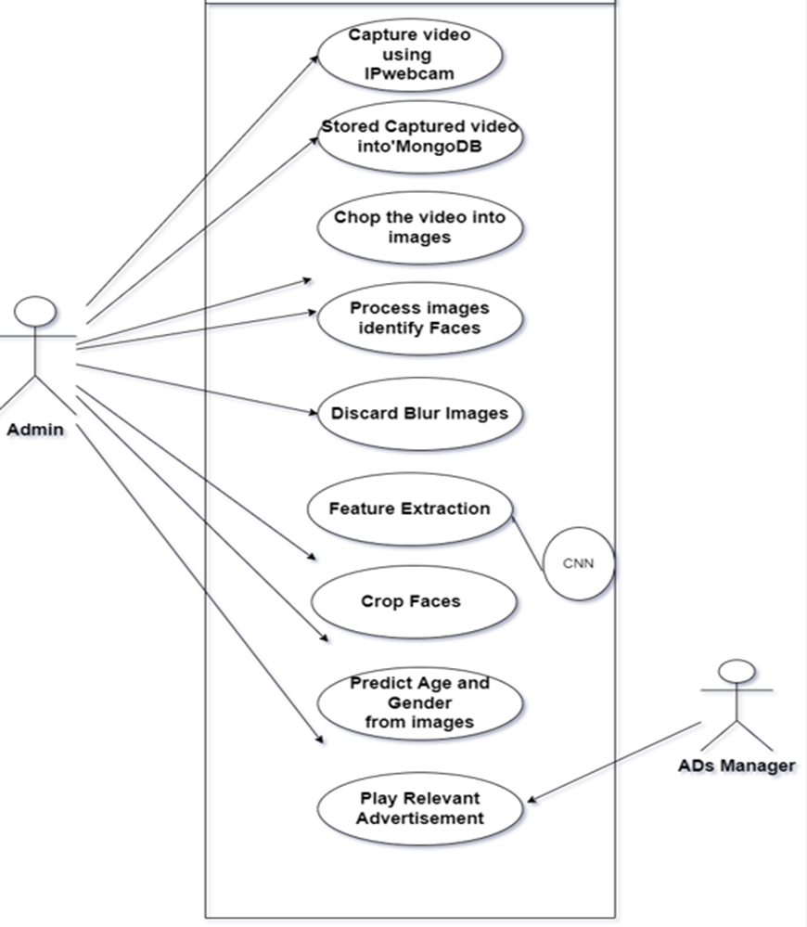

Fig. 4.2.1 Use case diagram for playing advertisements based on gender and age

**Use Case Diagram for (Vehicle Number Plate Recognition**)

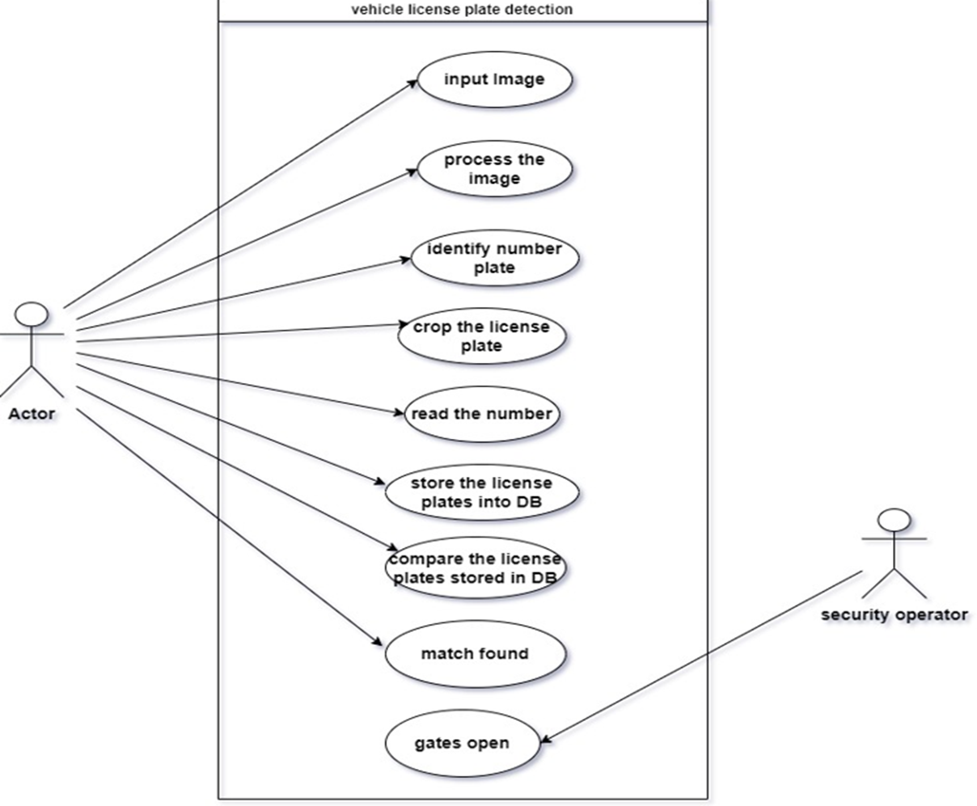

**Fig. No. 4.2.2** Use case diagram for vehicle number plate recognition

### **4.2.2 SEQUENCE DIAGRAMS**

The If the lifeline is that of an object, it demonstrates a role. Leaving the instance name blank can represent anonymous and unnamed instances.

Messages, written with horizontal arrows with the message name written above them, display interaction. Solid arrowheads represent synchronous calls, open arrowheads represent asynchronous messages, and dashed lines represent reply messages. If a caller sends a synchronous message, it must wait until the message is done, such as invoking a subroutine. If a caller sends an asynchronous message, it can continue processing and doesn’t have to wait for a response. Asynchronous calls are present in multithreaded applications and in message-oriented middleware. Activation boxes, or method-call boxes, are opaque rectangles drawn on top of lifelines to represent that processes are being performed in response to the message (Execution Specifications in UML). Objects calling methods on themselves use messages and add new activation boxes on top of any others to indicate a further level of processing.

When an object is destroyed (removed from memory), an X is drawn on top of the lifeline, and the dashed line ceases to be drawn below it (this is not the case in the first example though). It should be the result of a message, either from the object itself, or another. A message sent from outside the diagram can be represented by a message originating from a filled-in circle (found in UML) or from a border of the sequence diagram (gate in UML). UML has introduced significant improvements to the capabilities of sequence diagrams. Most of these improvements are based on the idea of interaction fragments which represent smaller pieces of an enclosing interaction. Multiple interaction fragments are combined to create a variety of combined fragments, which are then used to model interactions that include parallelism, conditional branches, and optional interactions. When an object is destroyed (removed from memory), an X is drawn on top of the lifeline, and the dashed line ceases to be drawn below it (this is not the case in the first example though). It should be the result of a message, either from the object itself, or another. A message sent from outside the diagram can be represented by a message originating from a filled-in circle (found message in UML) or from a border of the sequence diagram (gate in UML).

**Sequence Diagram for Playing Advertisements Based on Gender and Age**

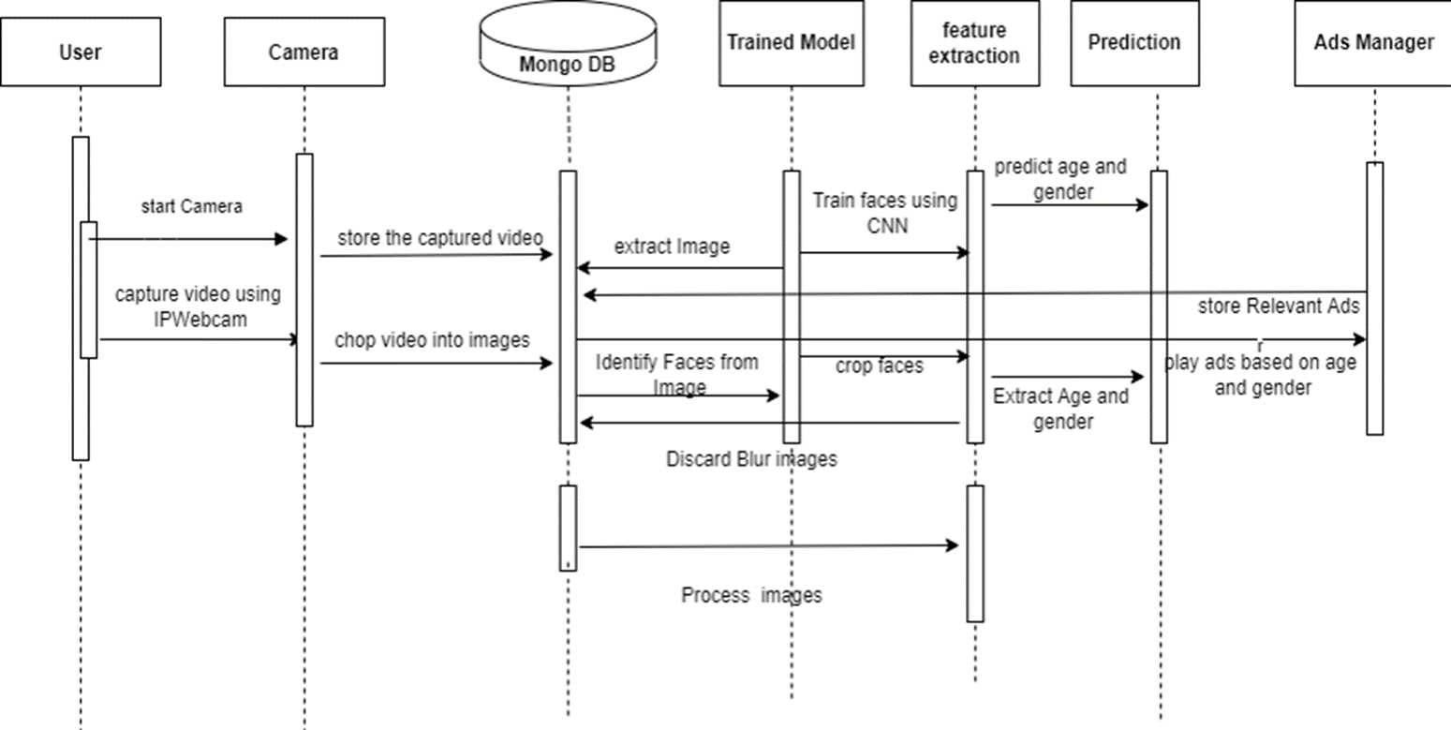

**Fig No. 4.2.3** Sequence diagram for playing advertisements based on gender

### **4.2.3 ACTIVITY DIAGRAM**

Activity diagram is another important diagram in UML to describe the dynamic aspects of the system. Activity diagram is basically a flowchart to represent the flow from one activity to another activity. The activity can be described as an operation of the system. The control flow is drawn from one operation to another. This flow can be sequential, branched, or concurrent. Activity diagrams deal with all type of flow control by using different elements such as fork, join, etc.

**Purpose of Activity Diagrams**

The basic purpose of activity diagrams is similar to the other four diagrams. It captures the dynamic behaviour of the system. Other four diagrams are used to show the message flow from one object to another, but the activity diagram is used to show the message flow from one activity to another. Activity is a particular operation of the system. Activity diagrams are not only used for visualizing the dynamic nature of a system, but they are also used to construct the executable system by using forward and reverse engineering techniques. The only missing thing in the activity diagram is the message part. It does not show any message flow from one activity to another. Activity diagram is sometimes considered as the flowchart. Although the diagrams look like a flowchart, they are not. It shows different flows such as parallel, branched, concurrent, and single.

The purpose of an activity diagram can be described as −

* Draw the activity flow of a system.
* Describe the sequence from one activity to another
* Describe the parallel, branched, and concurrent flow of the system.

**How to Draw an Activity Diagram?**

Activity diagrams are mainly used as a flowchart that consists of activities performed by the system. Activity diagrams are not exactly flowcharts as they have some additional capabilities. These additional capabilities include branching, parallel flow, swimlane, etc.

Before drawing an activity diagram, we must have a clear understanding about the elements used in activity diagram. The main element of an activity diagram is the activity itself. An activity is a function performed by the system. After identifying the activities, we need to understand how they are associated with constraints and conditions.

Before drawing an activity diagram, we should identify the following elements −

* Activities
* Association
* Conditions
* Constraints

Once the above-mentioned parameters are identified, we need to make a mental layout of the entire flow. This mental layout is then transformed into an activity diagram.

Following is an example of an activity diagram for an order management system. In the diagram, four activities are identified which are associated with conditions. One important point should be clearly understood that an activity diagram cannot be exactly matched with the code. The activity diagram is made to understand the flow of activities and is mainly used by the business users. Following diagram is drawn with the four main activities

* Send order by the customer
* Receipt of the order
* Confirm the order
* Dispatch the order

After receiving the order request, condition checks are performed to check if it is normal or special order. After the type of order is identified, dispatch activity is performed and that is marked as the termination of the process.

These systems can be databases, external queues, or any other system.

We will now look into the practical applications of the activity diagram. From the above discussion, it is clear that an activity diagram is drawn from a very high level. So, it gives a high-level view of a system. This high-level view is mainly for business users or any other person who is not a technical person.

This diagram is used to model the activities which are nothing but business requirements. The diagram has more impact on business understanding rather than on implementation details.

Activity diagram can be used for −

* Modelling workflow by using activities.
* Modelling business requirements.
* High level understanding of the system's functionalities.
* Investigating business requirements at a later stage.

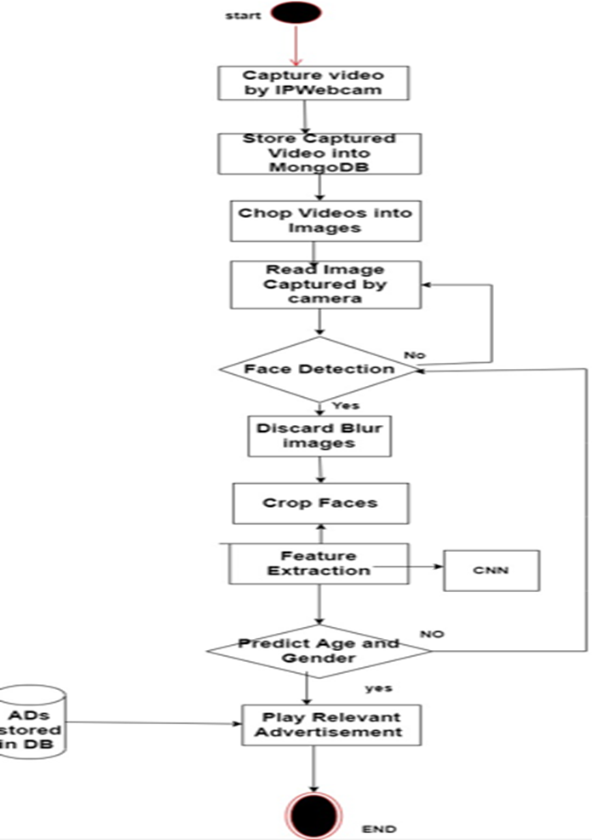

Fig. 4.3 Activity Diagram for Playing Advertisement based on Age and gender

**Activity Diagram for vehicle number plate Recognition**

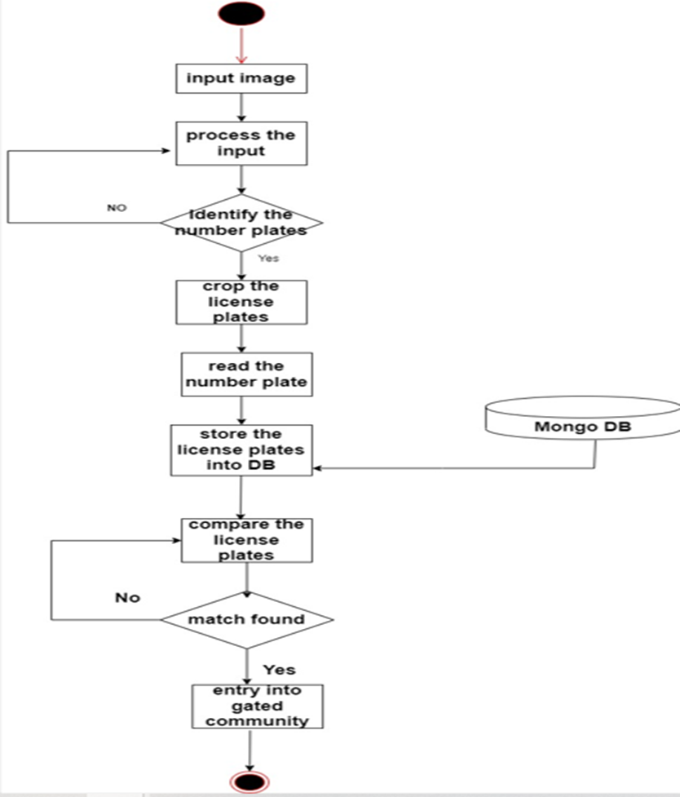

**Fig No. 4.4** Activity diagram for vehicle number plate recognition

# **5. METHODOLOGY**

The Kenexoft’s SDME (Smart Device Mana) this framework is to be used for the automatic monitoring that is, first we access the camera from any IP enabled camera and we get that video next we will chop this video into the frames or the images after chopping of the images we will check any blur images and we will delete those unnecessary images/frames and next we will move the images folder into the cloud technology like AWS or any other cloud to make easy to maintain and access the images after retrieving images from the cloud, now we will detect the images from the folder and classify the gender and then we will play the relevant Advertisement based on Gender

* Camera Access from IP enabled Camera
* Chop the Video taken from the IP enabled Camera
* Delete the unwanted images/frames from the images Folder
* Upload the images folder into the AWS cloud
* Retrieve / access the images from the cloud into the Program
* Detect the images and classify their gender and age
* Based on their gender and age we will play the relevant Advertisement
* Advertisement for different ages and different genders
* Detecting the vehicle along with the number on the number plate
* Matching the data of vehicle number stored in the database

**Camera Access:**

This Module helps to access the camera of the device for monitoring the content. Which can be used for storing the data, detecting the age and gender, Capturing the vehicle number plates

**Chopping the Video:**

We have chopped the Video that was taken by the IP enabled into the frames / images it should be more images so that we can efficiently classify the gender

**Deleting the Chopped Images:**

After Chopping the video, we will get more images that unnecessary images and blurred images these type of images should be deleted and remaining images create a folder

**Uploading Data to Cloud Database:**

This module mainly focuses on uploading the Images Folder footage into the database. Which can be used for any security purpose and to access easily from the Cloud

**Retrieving Data from Database:**

This Module helps in retrieving the stored content in the database especially the videos as the data is stored in the various containers.

As MongoDB has a limit for storing the video file**.**

**Gender and Age Detecting:**

ThisModule is one of the core parts, which plays a major role for detecting the age and gender depending on which the advertisements are displayed.

**Playing Advertisements According to Gender:**

This Module is responsible for playing videos so called the advertisements depending on the output provided in the previous module. It plays videos related to females and respectively. This can be customized depending on the area of its usage.

**Detecting Vehicle Number Plate Along with The Number on The Plate:**

It is the other core part. In this we try to detect the number plate of the car and recognize the content of the number plate, which is used for detecting, Whether the car belongs into the community or outside of the community.

**Matching the data of captured number plates from stored Database:**

In This module we compare the vehicle number plates with the community number plates which are stored in the database. If there is a match, then that particular vehicle belongs to the community.

**SDME WORK FLOW DIAGRAM**

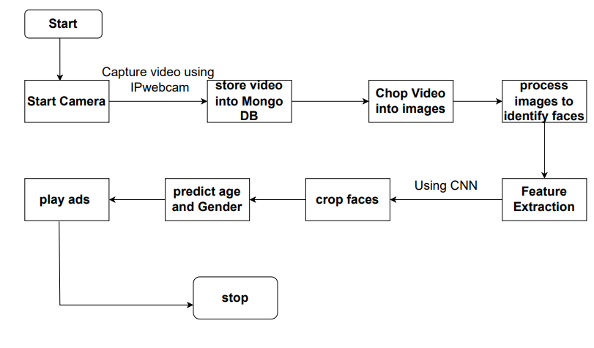

Fig 5.1 Work Flow Diagram of SDME

**VEHICLE NUMBER PLATE RECOGNITION FLOW DIAGRAM**

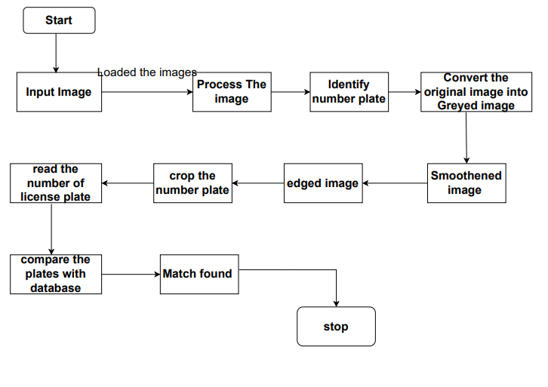

Fig 5.2 Vehicle Number Plate Recognition Flow Diagram

# **6. TESTING**

Proper testing methodologies and procedures become even more crucial to adopt and deploy SDME project within their companies in order to make the transition to as smooth as feasible. SDME’s testing procedures are similar to other types of software testing in certain aspects, but they differ in others. Some major takeaways from previous implementations are listed below.

## **6.1 STEPS IN TESTING PROJECT**

* **Understand the Project**
* **Test scenarios**
* **Test scripts**
* **Test the data**
* **Manage defects**

### **6.1.1 UNDERSTAND THE BUSINESS PROCESS**

As a project gets executed, it will undergo numerous adjustments. The primary goal of the test team should be to completely understand the newly automated process before any testing operations can commence. This is one of the most crucial processes in the test cycle since it establishes the groundwork for the subsequent steps. First Access the Video from the IP enabled camera from which the video is been chopped into the frames and in that many frame images we will delete the unnecessary Blur Images from the folder and upload the remaining images into the Cloud/Database and then by the Convolutional Neural Networks we will process the images and snapshots and classify the gender using the gender detection model and play the relevant advertisement based on the gender.

### **6.1.2 TEST**

Now it's time to double-check that the automation was built in accordance with the business rules outlined in the design documentation. The key to having good test scenarios is to make sure they're clear, succinct, and cover all of the PDD/business SDD's rules. The SDD usually outlines the needed scenarios that must be validated during testing, but it's also a good idea to go over the process flows and double-check the SDD for any missing information.

### **6.1.3 TEST SCRIPTS**

This stage requires putting together the information you’ve previously gathered. The test script is made up of numerous test cases with a variety of explicit outcomes. It is typically in an Excel format and will contain the test scenarios, input data requirements for testing the scenarios, expected and actual results, and a pass or fail column. Like the test scenarios, it is best to write the script clearly and concisely. The more thorough the script, the less chance of gaps or missed test scenarios. Depending on the complexity of the process, it can be a good idea to have the design team review the script and make any changes or suggestions. This additional step can help eliminate any gaps that may arise during testing.

### **6.1.4 TEST THE DATA**

Test data is the fuel for the fire. Without valid test data, automation testing can lead to inaccurate test results, which can lead to invalid defects, often creating a strain on the testing timeline. This is why it’s important to have a clear understanding of what type of data and format you need for a successful testing cycle.

### **6.1.5 MANAGE THE DEFECTS**

As expected with any automation testing, defects will be found. The team must document the defects and notify the development team. The key to effective defect management is detail. The more information the test team can provide, the quicker the correction can be made. Some ways to provide details include: writing the test-case description, taking a screenshot of the error, recording where the process is failing, attaching the input file used to test, and attaching the output file produced by the automation.

# **7. OUTPUT & SAMPLE CODE**

The final output after completing the project and these are output Modules wise

1. **Capturing video Using IP Enabled Camera**

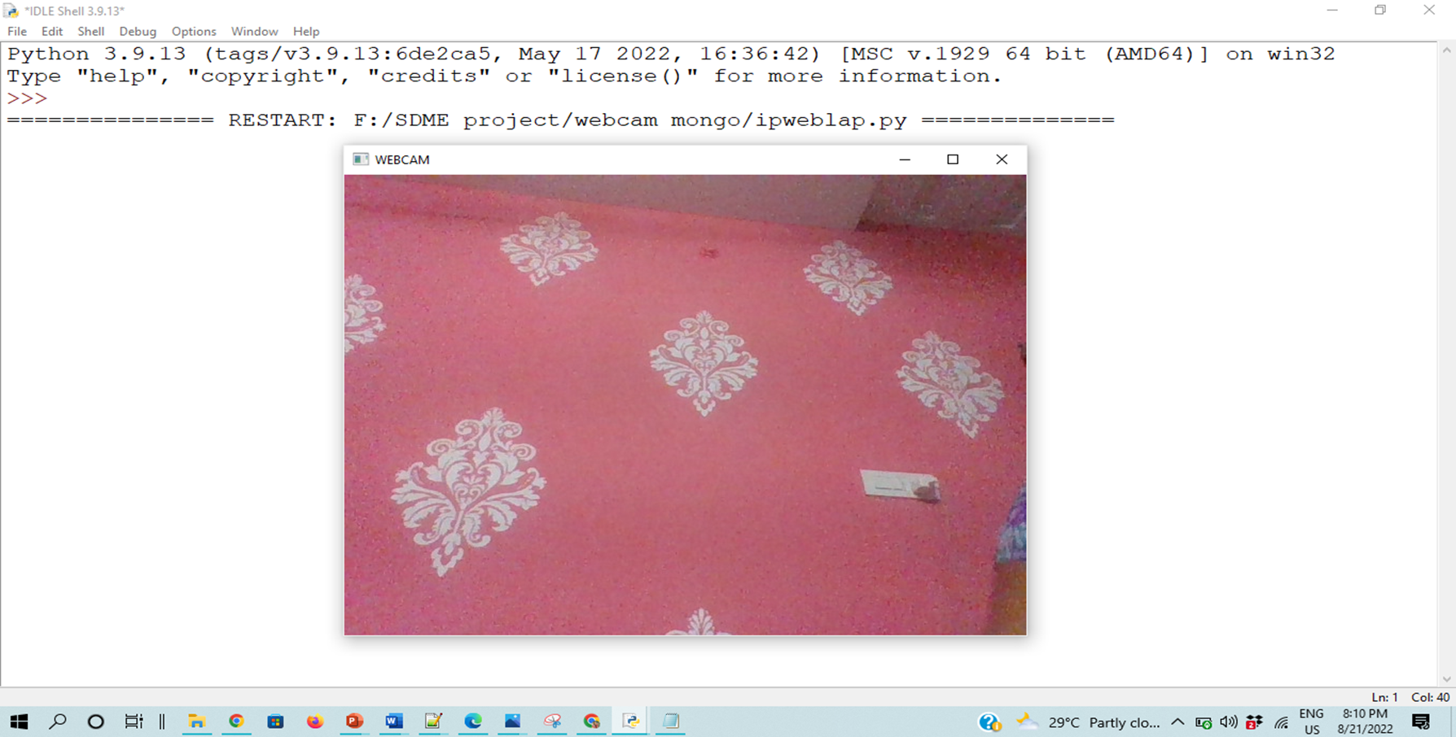

**Fig 7.1** Capturing video using IP Camera

Here the video which is to be chopped into frames that Video We are Capturing the Video from Any IP enabled Camera

**2) Uploading Images into database**

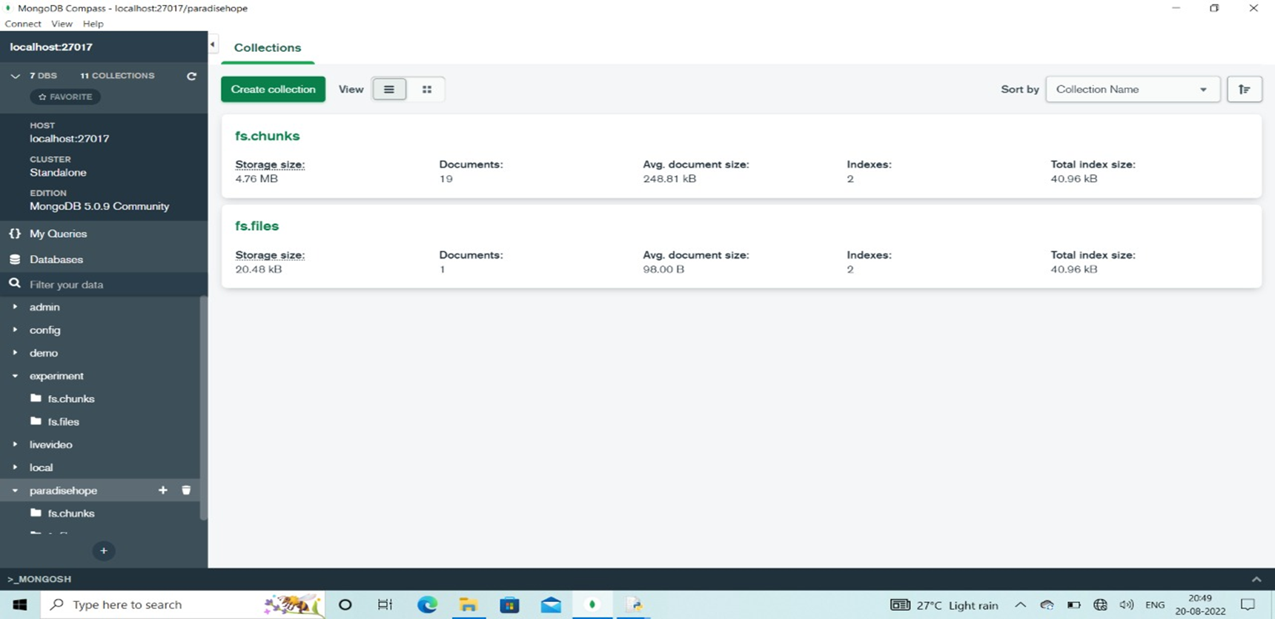

**Fig 7.2** UploadingImages into database

**3) Chopping the video into images**

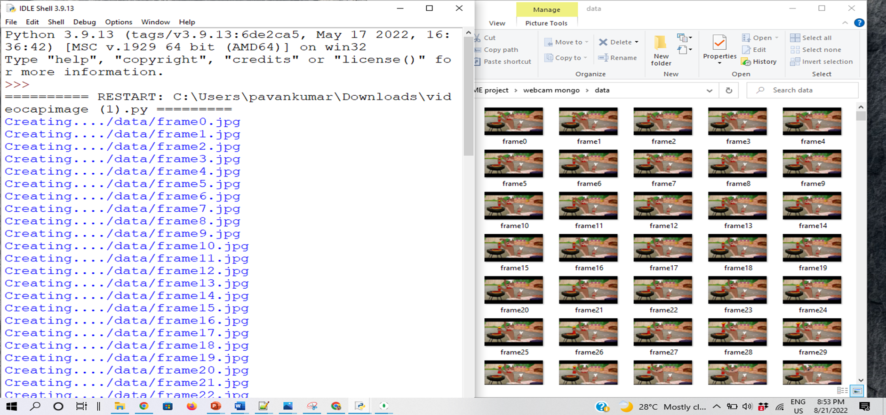

**Fig 9.3** Chopping the video into frames

**4) Detecting age and gender of a person**

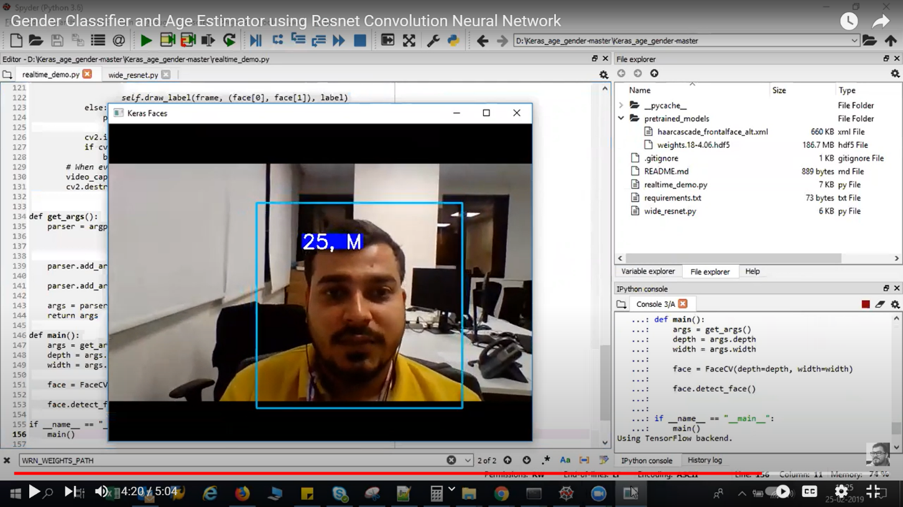

**Fig 7.4** Detecting age and gender of a person

**5) Playing Relevant advertisement based on age and gender**

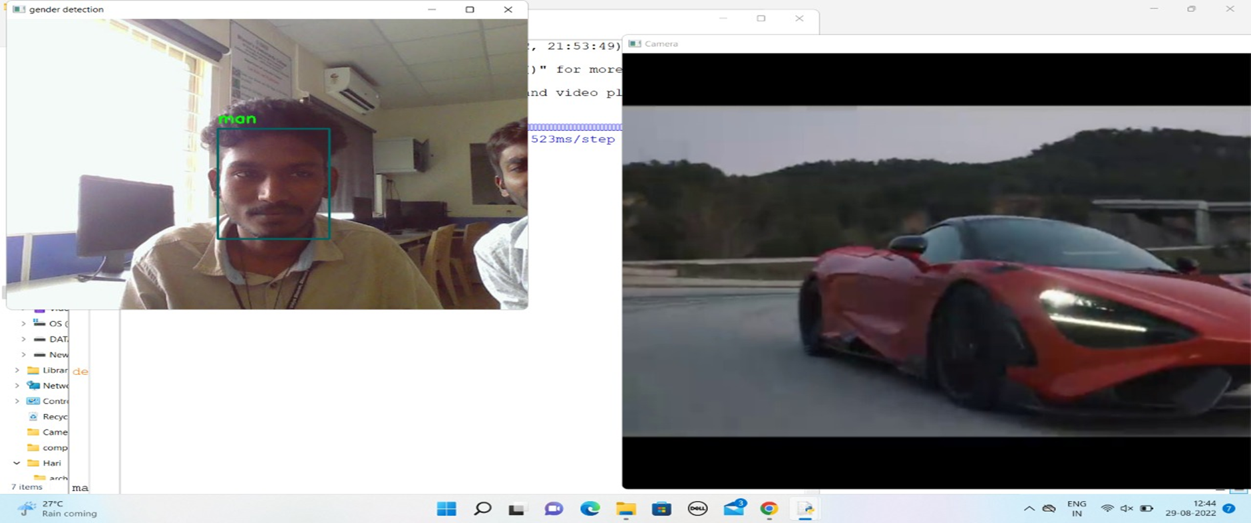

**Fig 7.5** Playing ads according to gender

**6) Playing Car Advertisement for Men**



**Fig 7.6** Advertisement for men

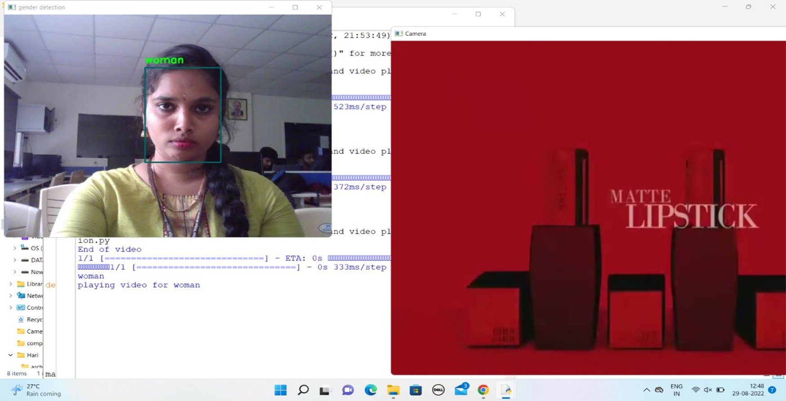

**Fig 7.7** Detecting gender and playing relevant advertisement

**Playing Relevant Advertisement For women (Lipstick Ad)**



**Fig No. 7.8** Advertisement for female

**Identifying vehicle license plates for vehicle number recognition**

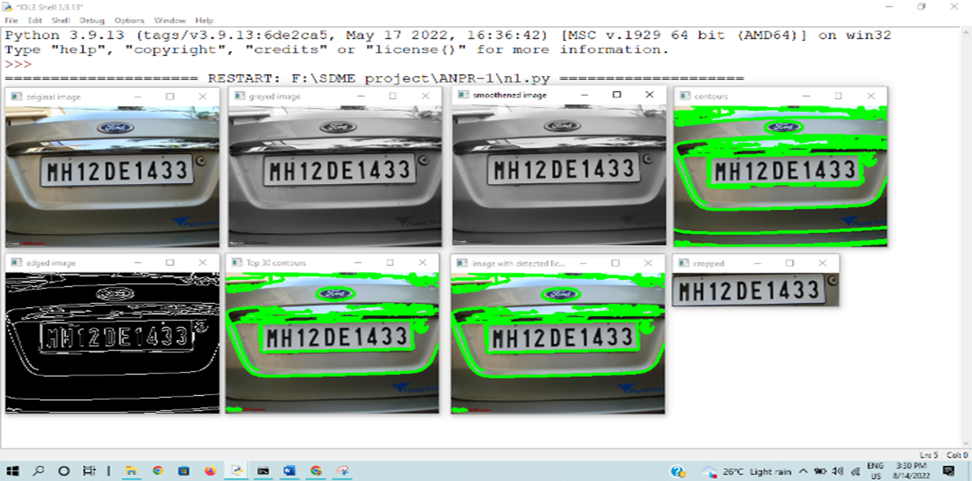

**Fig 7.9** Detecting vehicle number plate and text on the plate

**SAMPLE CODE**

**Code To Capture Video Using IP webcam**

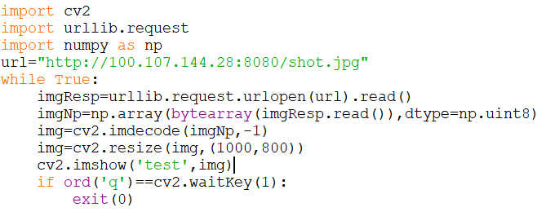

**Uploading Video to MongoDB**

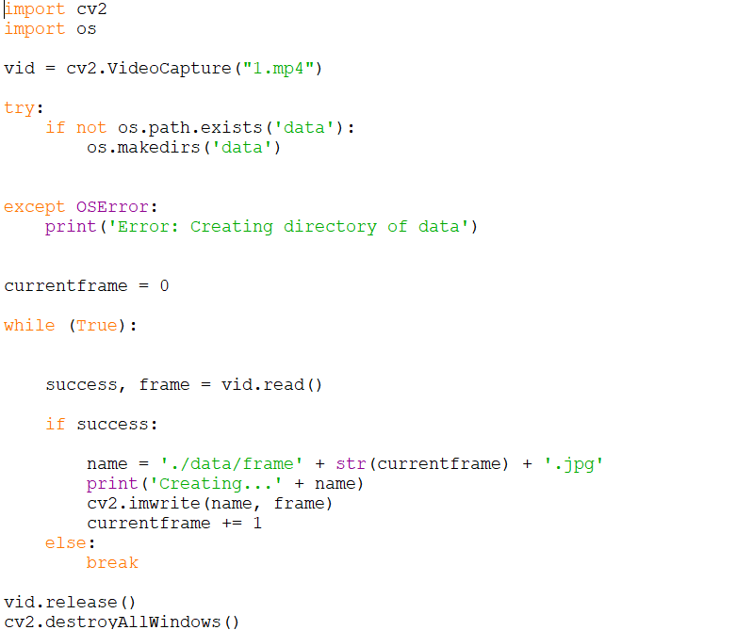

**Storing Video to MongoDB**

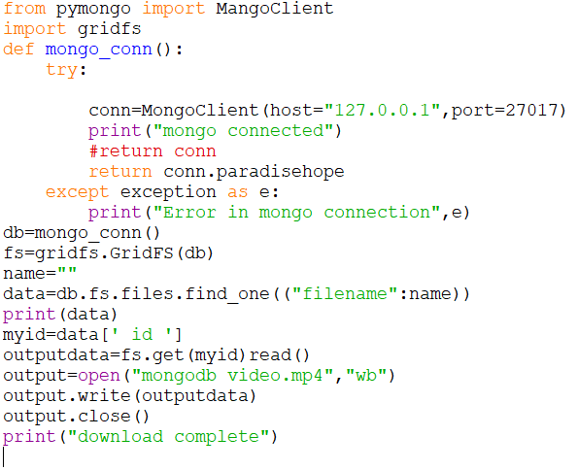

**Predicting Age and Gender**

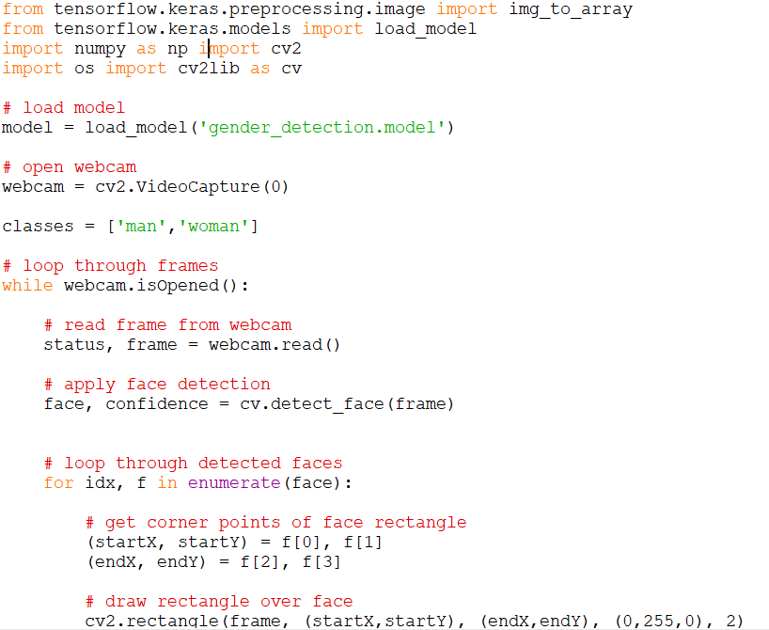

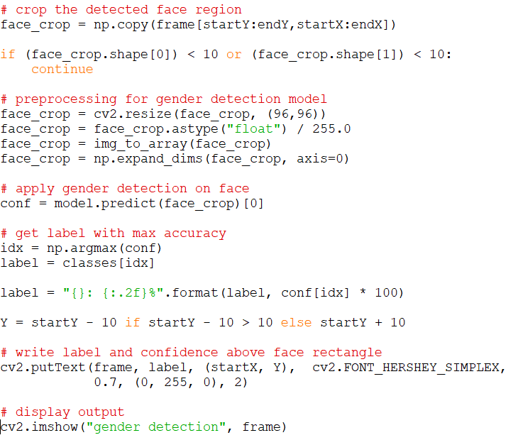

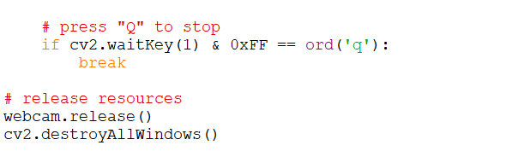

**Playing ADs Based on Gender**

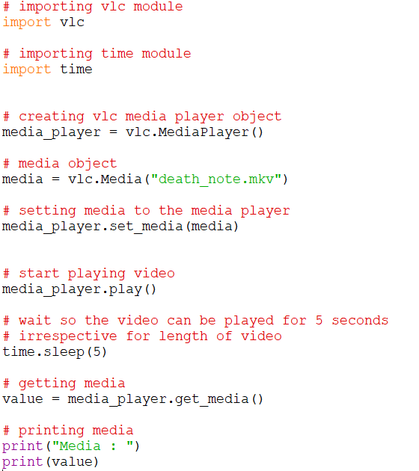

**Vehicle Number Plate Recognition**

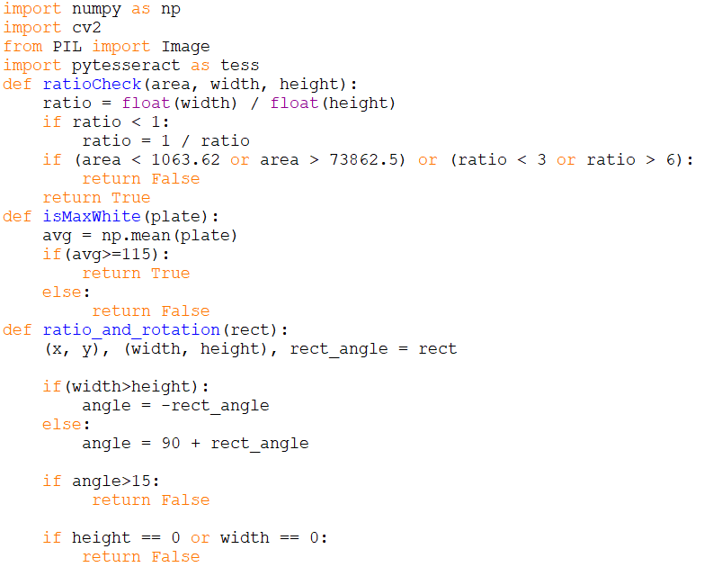

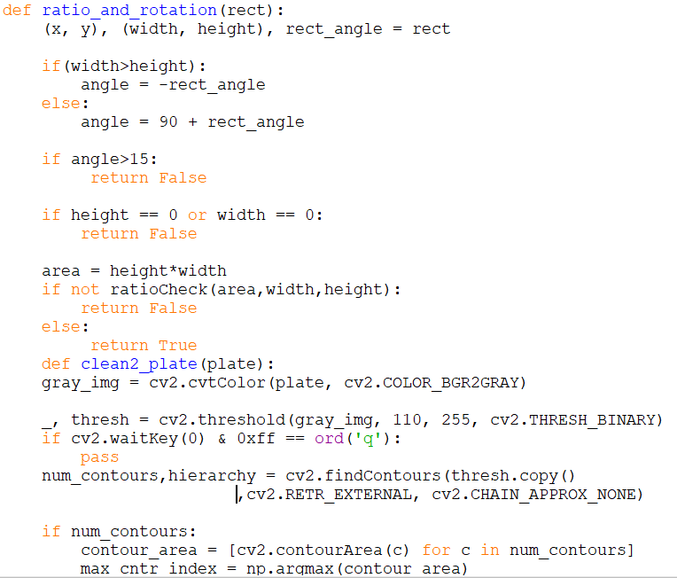

# **8. CONCLUSION**

The Smart Digital Monitoring Engine makes an effort to minimise human involvement.

This advertising, which can be seen in malls and other public locations, is successful because it targets the age and gender of people in a particular region. It plays appropriate commercials based on a person's gender, which is more effective at boosting sales at the store because it attracts the viewer's attention. In gated communities, the vehicle licence plate recognition system is quite helpful since it keeps the area safe and identifies unauthorised vehicles.

The Future Scope of the project, the implementation of vehicle detection, which requires reading the text on the licence plate and determining whether the vehicle is a member of the community or not by comparing the text with previously registered vehicle numbers that are stored in the database, will be included in the following version. By doing so, we will be able to employ this paradigm in two situations.

To only permit registered and approved vehicles to enter the community

To create a surveillance system with the purpose of keeping an eye on vehicles entering the community.

The project will be finished by completing the mentioned objectives.

**REFERENCES**

[1] J. Gou, L. Gao, P. Hou, and C. Hu, ―Gender recognition based on multiple scale textural feature,‖ presented at the 5th International Congress on Image and Signal Processing, Sichuan, China, October16-18, 2012.

[2] G. Levi and T. Hassner. Age and gender classification using convolutional neural networks. In IEEE Conf. on Computer Vision and Pattern Recognition (CVPR) workshops, June 2015.

[3] E. Eidinger, R. Enbar, and T. Hassner. Age and gender estimationof unfiltered faces. Trans. on Inform. Forensics andSecurity, 9(12), 2014S. Baluja and H. A Rowley.Boosting sex identification performance.Int. J. Comput. Vision, 71(1):111–119, 2007.

[4] W.-L. Chao, J.-Z.Liu, and J.-J. Ding. Facial age estimation based on label-sensitive learning and age-oriented regression. Pattern Recognition, 46(3):628–641, 2013

[5] S. E. Choi, Y. J. Lee, S. J. Lee, K. R. Park, and J. Kim. Age estimation using a hierarchical classifier based on global andlocal facial features. Pattern Recognition, 44(6):1262–1281,2011.

[6] C. Cortes and V. Vapnik. Support-vector networks. Machine learning, 20(3):273–297, 1995.E. Eidinger, R. Enbar, and T. Hassner. Age and gender estimation of unfiltered faces. Trans. on Inform. Forensics and Security, 9(12), 2014.

[7] A.C.Gallagher and T. Chen. Understanding images of groups of people. In Proc. Conf. Comput. Vision Pattern Recognition, pages 256–263. IEEE, 2009

[8] B. A. Golomb, D. T. Lawrence, and T. J. Sejnowski. Sexnet:A neural network identifies sex from human faces. In NeuralInform. Process. Syst., pages 572–579, 1990d

[9] G. Guo, Y. Fu, C. R. Dyer, and T. S. Huang. Imagebasedhuman age estimation by manifold learning and locallyadjusted robust regression. Trans. Image Processing,17(7):1178–1188, 2008.

[10] G. Guo, G. Mu, Y. Fu, C. Dyer, and T. Huang. A study on automatic age estimation using a large database. In Proc. Int Conf. Comput. Vision, pages 1986–1991.IEEE, 2009.Neural Inform. Process. Syst., pages 1097–1